George

&

D
ragon

Christmas Day Lunch

~ 1pm
–

3
pm

£49.95

per head

Mulled wine on arrival

To start

Winter

vegetable soup,

served
with crusty bread,

butter & herb

croutons
(
V
)

Prawn
cocktail with chilli & lime, served with brown bread & butter

Baked flat mushroom, served in a creamy blue cheese sauce

(
V
)

Chicken liver paté served with toasted ciabatta slices & onion chutney

M
ains

Thyme roasted
turkey, served with
roast potatoes,

fresh vegetables,

a homemade
Yorkshire pudding,

homemade stuffing and rich gravy

W
hole roasted seabass served with garlic & herb roasted new
potatoes & a warm
tomato salsa

Vegetarian cauliflower cheese grills

served with
roast potatoes, homemade Yorkshire
pudding,
fresh vegetables, homemade stuffing & vegi gravy (v)

Dessert

Christmas pudding
served
with brandy cream

Sticky toffee pudding
served
with
vanilla custard

Warm chocolate fudge cake served with chocolate ice cream

Cheese plate, cheddar,

brie & blue
cheese
served
with crackers, chutney,

celery sticks
& grapes

Slow braised lamb, served with garlic & rosemary mashed potato, a selection of veg & gravy

Tea or coffee and mince pies

£20 non-refundable deposit required per person and pre order is essential

85 Castle Street, Salisbury, Wiltshire, SP1 3SP
T: 01722 333122 E: info@georgeanddragonpub.co.uk
Website: www.georgeanddragonpub.co.uk

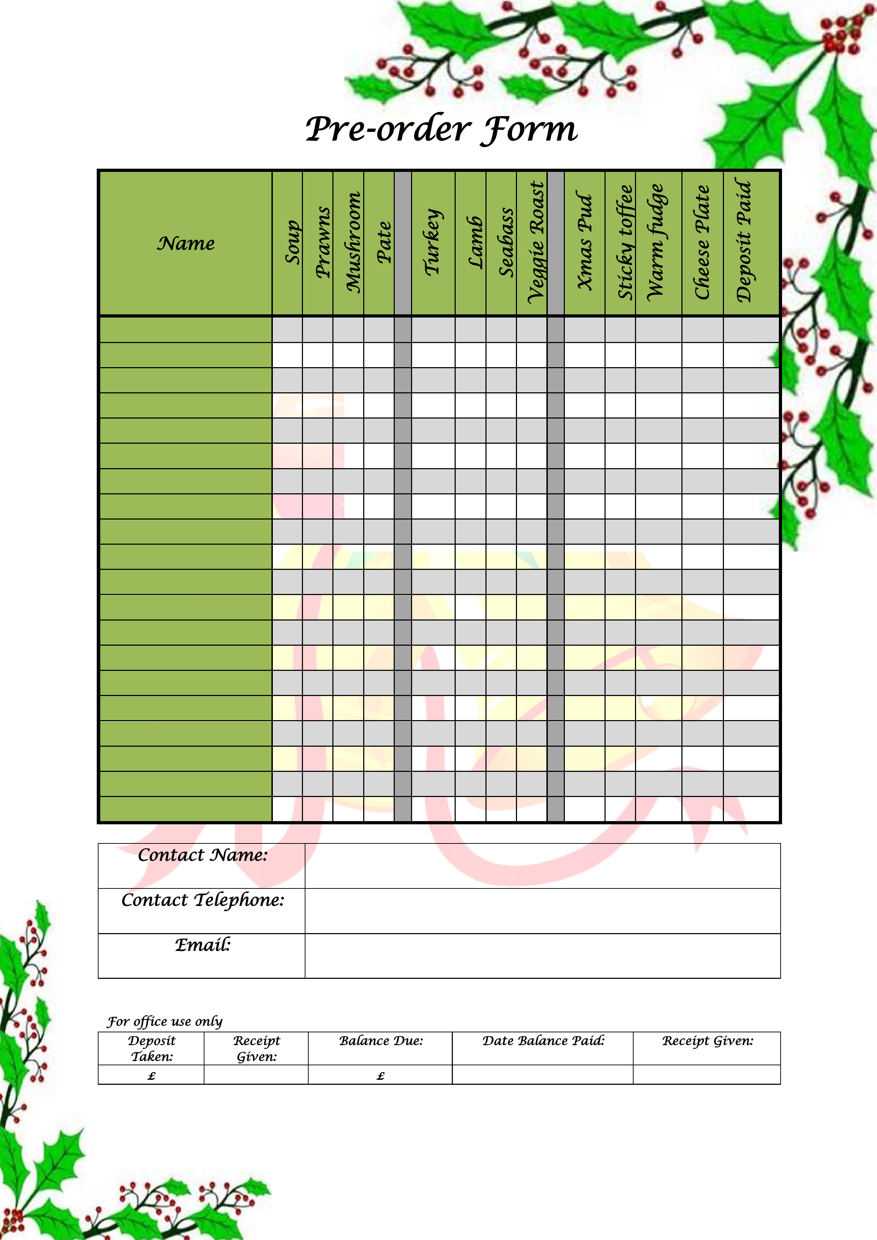
85 Castle Street, Salisbury, Wiltshire, SP1 3SP
T: 01722 333122 E: info@georgeanddragonpub.co.uk
Website: www.georgeanddragonpub.co.uk

